**My Doubts:**

1. My Designation
2. As Consultant or As Developer or as DevOps (DevOps is as hard as being a developer, but in different ways. They both can be challenging.)
3. In Cloud so many Designation
4. In AWS so may Designation
5. According to designation, will choose the technologies because don’t know it require how much coding, tools and all

Developers are responsible for creating software programs and may produce several while they work with an organization. In contrast, those in DevOps may take the program a developer creates and makes changes to it to automate its processes and integrate it into the existing structure of an organization.

DevOps engineers are more frequently stressed than the IT average. Over 40% admit to being stressed 'often' or 'very often' compared to 34% of the IT average.” The study suggests that DevOps are the most stressed because they feel their skills are insufficient for their jobs

**In company website**

**Cloud Consulting Services and Application Development**

[**https://www.arcassetz.com/cloud-application-development/**](https://www.arcassetz.com/cloud-application-development/)

Cloud consulting is the process where an organization leverages cloud consultants to build, operate, manage and maintain an optimal cloud environment. Cloud consulting accelerates business growth and innovation, drives agility, transforms operational efficiency and ensures performance and security in the cloud.

To become a cloud consultant, you need to have a solid foundation of technical skills, such as programming, networking, database, security, and DevOps. You also need to have knowledge of the cloud platforms and services that you specialize in, such as AWS, Azure, Google Cloud, or Salesforce

You can demonstrate your expertise by earning relevant certifications from these providers, such as AWS Certified Solutions Architect, Azure Solutions Architect Expert, Google Professional Cloud Architect, or Salesforce Certified Technical Architect. Additionally, you need to have business skills, such as project management, problem-solving, analytical thinking, and customer service. You also need to have communication skills, such as presentation, negotiation, listening, and writing.

[**DevOps Engineer**](https://www.geeksforgeeks.org/how-to-become-a-devops-engineer-a-complete-roadmap/)**:**   
DevOps engineer is an IT person who is a part of both development and operation means DevOps engineers work on code with the developer team, oversee the code releases, and also manages the deployment and operation processes. For proper integration and running of software, they work with the product operation team also.

A DevOps engineer requires knowledge of programming, management, Knowledge of agile and DevOps principles, problem-solving skills, organizational skills, etc.

The job roles and responsibilities of a DevOps engineer include.

* Accessing the technological automation tools
* Managing the cloud deployment
* Leading the software development team
* Maintaining compliance and security controls
* Monitoring operations
* Working and Improving the A software development process

|  |  |
| --- | --- |
| **main focus of software engineers is to develop a good software product to meet the requirement of the client.** | **While the main focus of DevOps engineers is to deploy and smooth the operation of the software product.** |
| **In general Software engineers get less salary than DevOps engineers with the same experience.** | **In general DevOps engineer with same experience gets 25-35% more salary with the same experience.** |

##### **What are the business benefits of cloud consulting?**

The most significant business benefits of cloud consulting include:

* **Seamless integration.** Many cloud-based platforms integrate seamlessly with new technologies.
* **Scalability.** Cloud consulting offers a high level of flexibility with a robust scalable platform, so organizations can quickly scale up or down to meet demand. Solve immediate business issues with on-demand sustainable, scalable cloud solutions.
* **Modernized applications.** Manage modernized applications on any platform at any time with industry-specific cloud services.
* **Cost savings.** Reduce network maintenance and management costs and increase ROI with artificial intelligence (AI) and automation.
* **Cost efficiency.** Pay-per-use, cloud-based models let businesses use only as much space as needed, with real visibility and cost controls.
* **Robust governance.** Ensure controlled cloud usage and better visibility by bringing in cloud consulting, including technology and service governance.
* **Increased security.** Use continuous security and compliance to ensure the safety of valuable data and secure infrastructure 24/7.
* **Automatic software updates.** Automatically update software, manage and maintain the cloud infrastructure and deliver enhanced security around-the-clock.
* **Improved collaboration.** Cloud infrastructure enables groups and communities in different locations to work together and access the same files, significantly enhancing collaboration.
* **Business continuity.** Data stored in the cloud is mirrored across another server/location, so if one fails, data is instantly backed up. When you have reliable cloud consulting, your data is backed up on the cloud 24/7.
* **Resiliency and business continuity.** Focus on availability, fault-tolerance and disaster recovery to ensure business continuity and resiliency. Expand and accelerate business opportunities using resilient industry clouds, delivering intelligence, visibility and smart technologies at speed and scale.
* **Operational efficiency.** Use cloud consulting and the automated management of cloud resources to reduce manual intervention and increase organizational efficiency that drives robust business outcomes.

https://www.koombea.com/blog/what-is-cloud-application-development/

Cloud app is one that uses Cloud-based services. So, whether an app is mobile or web, they probably use some sort of Cloud service.

Cloud services have opened up the possibility for many [web-based Cloud applications](http://www.koombea.com/services/web-development), also known as web apps. A web app is one where most of the computation occurs in the Cloud, not on the device itself, and is usually built with the use of [Cloud application development services](https://www.koombea.com/services/cloud-application-development/). A new form of a web app, known as a [Progressive Web App (PWA)](https://www.koombea.com/blog/your-business-needs-a-progressive-web-app-pwa-and-heres-why/), is also seeing an increase in popularity.

Although some businesses have their own Cloud development teams, most will hire an app development company with experience in Cloud services

## Cloud Application Example

## Many of the apps we use on a day-to-day basis use the Cloud in one way or another. Cloud application development has resulted in amazing tools and services like:

* [Miro](http://www.miro.com/): a virtual board where you can work with other users in a number of fun and creative ways.
* [Figma](http://www.figma.com/) or [Lunacy](https://icons8.com/lunacy): a powerful Cloud-based design app that is gaining many fans thanks to its collaborative nature.
* [Dropbox](http://www.dropbox.com/) or [>Google Drive](https://www.google.com/drive/): easily store your files on the Cloud and make them available for others, wherever they are.

Collaboration is one element that stands out from most Cloud-based apps. Although there are other important ones, the possibility to collaborate with users from all over the world, even in real-time, is one major advantage of Cloud apps.

## Cloud Integration Services

## Cloud integration is a system of tools and technologies that connects various applications, systems, repositories, and IT environments for the real-time exchange of data and processes.

Cloud integration services refer to a set of tools and technologies that enable the connection and seamless interaction between different cloud-based applications, data, and services. These services are essential in today's business environment, where organizations often rely on a variety of cloud-based solutions for different aspects of their operations

Many businesses use multiple cloud-based applications for different purposes, such as customer relationship management (CRM), enterprise resource planning (ERP), and marketing automation. Cloud integration services help integrate these applications to streamline processes and data flows.

**Real-time Data Sync:** In many cases, it's crucial for businesses to have real-time data synchronization between various systems. Cloud integration services can provide mechanisms to ensure that data remains up-to-date across applications and services.

Several cloud integration services and platforms are available, such as Apache Camel, Apache NiFi, MuleSoft, Dell Boomi, Informatica, and Zapier. The choice of a specific service or platform depends on your organization's needs, existing technology stack, and integration requirements. These services help businesses harness the full potential of the cloud by ensuring that data and applications work together harmoniously, leading to increased efficiency, agility, and competitiveness.

Certainly! Let's briefly explain each of these cloud integration services and platforms, including whether coding is typically involved in their use:

1. Apache Camel:

- Description: Apache Camel is an open-source integration framework that focuses on routing and mediation rules for message routing. It provides a set of predefined components for connecting various systems and allows you to define routing rules in a domain-specific language.

- Coding Involvement: Camel uses domain-specific languages to define integration rules and routes, so some coding or scripting may be required to create complex integrations.

2. Apache NiFi:

- Description: Apache NiFi is an open-source data integration tool designed for data routing, transformation, and system connectivity. It provides a web-based interface for designing data flows.

- Coding Involvement: Apache NiFi emphasizes a user-friendly interface that allows users to create data flows without much coding. However, it also provides scripting capabilities for more advanced scenarios.

3. MuleSoft:

- Description: MuleSoft, developed by Salesforce, is an integration platform that offers a wide range of tools and services for connecting applications, data, and devices across the cloud and on-premises environments.

- Coding Involvement: While MuleSoft promotes a no-coding or low-coding approach, it does offer a visual design interface for building integrations. However, more complex or custom requirements may involve some coding in MuleSoft's proprietary language.

4. Dell Boomi:

- Description: Dell Boomi is a cloud-based integration platform as a service (iPaaS) that simplifies the process of connecting various applications and data sources.

- Coding Involvement: Dell Boomi is designed to be a low-code platform, making it accessible to non-developers. Still, some complex tasks may require scripting.

5. Informatica: ( Data Analytics )

- Description: Informatica offers a comprehensive suite of data integration and data management tools. It provides capabilities for ETL (Extract, Transform, Load) processes, data quality, and data governance.

- Coding Involvement: While Informatica is known for its user-friendly interface, some advanced data integration tasks may require SQL or scripting knowledge.

6. Zapier:

- Description: Zapier is a cloud-based automation platform that connects and automates workflows between various web applications and services. It uses a trigger-action model, allowing users to create "Zaps" that connect different services.

- Coding Involvement: Zapier is designed for users who are not developers. It focuses on a user-friendly, no-coding approach where users can set up integrations via a visual interface and predefined triggers/actions.

These tools and services are designed to cater to a wide range of users, from non-developers to experienced developers. The level of coding involvement depends on the complexity of the integration you need to achieve. In many cases, they offer user-friendly, visual interfaces that allow you to create integrations without extensive coding. However, for more advanced or custom scenarios, coding skills may come in handy, especially in platforms like Apache Camel or MuleSoft.

<https://www.informatica.com/in/resources/articles/cloud-integration-moves-businesses-forward.html> imp

cloud services such as:

* [Amazon Web Services (AWS)](https://www.informatica.com/in/solutions/explore-ecosystems/aws.html)
* [Google Cloud](https://www.informatica.com/in/solutions/explore-ecosystems/google-cloud-platform.html)
* [Microsoft Azure](https://www.informatica.com/in/solutions/explore-ecosystems/microsoft/azure.html)
* [Salesforce](https://www.informatica.com/in/solutions/explore-ecosystems/salesforce.html)
* [Snowflake](https://www.informatica.com/in/solutions/explore-ecosystems/snowflake.html)
* [Oracle](https://www.informatica.com/in/solutions/explore-ecosystems/oracle.html)

### **Power data analytics**

Cloud data integration brings all your data together in a highly accessible ecosystem. Data is cleaned and is ready for analysis. You can easily apply [artificial intelligence](https://www.informatica.com/blogs/unlocking-the-power-of-ai-with-data-management.html) (AI) and [machine learning](https://www.informatica.com/in/blogs/5-steps-to-operationalize-data-science-and-machine-learning-at-scale.html) (ML) on demand.

Cloud application integration gives you the ability to:

* Discover, connect, access and use your data in real time
* Improve workflows • Modernize your infrastructure
* Build models based on data insights
* Write programs for AI and machine learning to predict future behavior

Types of cloud computing IAAS, PAAS, CAAS, SAAS

# What is Cloud Computing?

<https://www.youtube.com/watch?v=8C_kHJ5YEiA>

<https://www.youtube.com/watch?v=8LEHFsmZwJg>

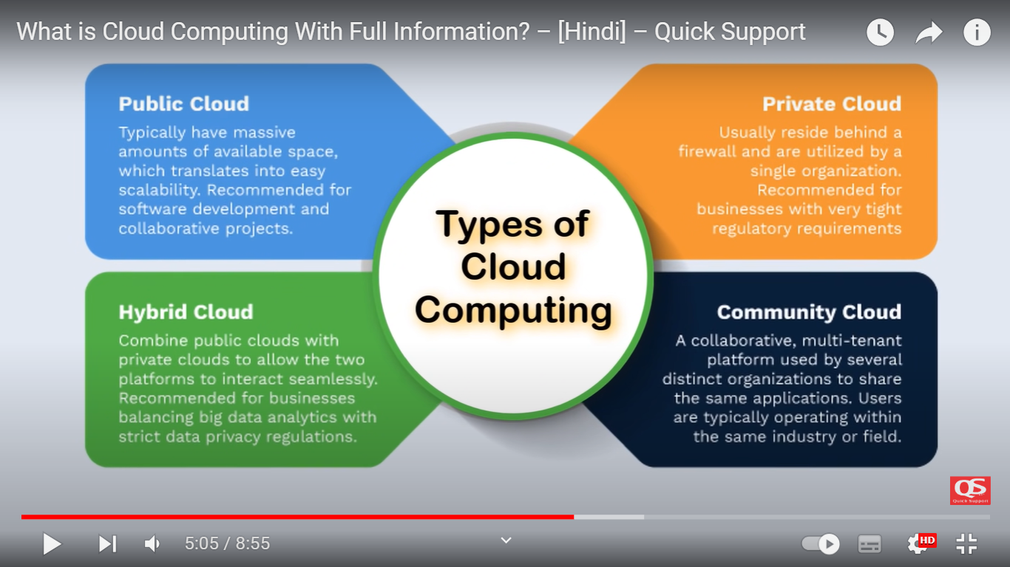

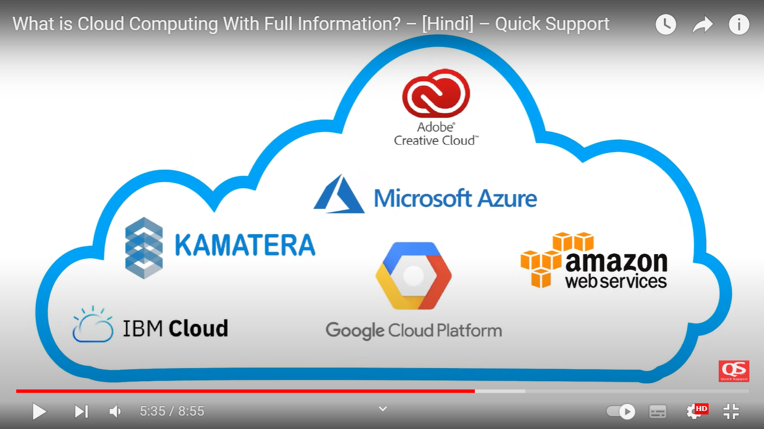

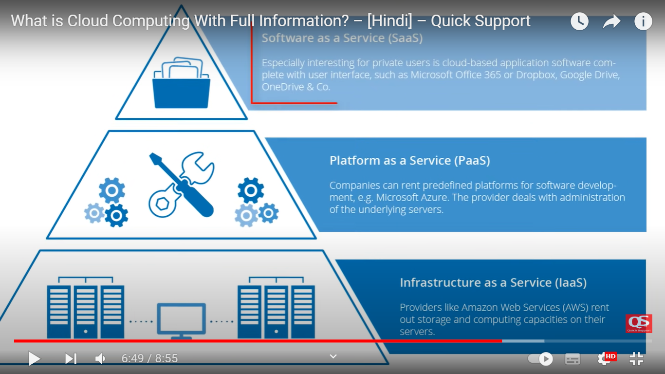

# Cloud or DevOps? | Which one should you learn first? | Understand in 3 minutes

<https://www.youtube.com/watch?v=8OMoVbjB5dU>

Start Learning Cloud First

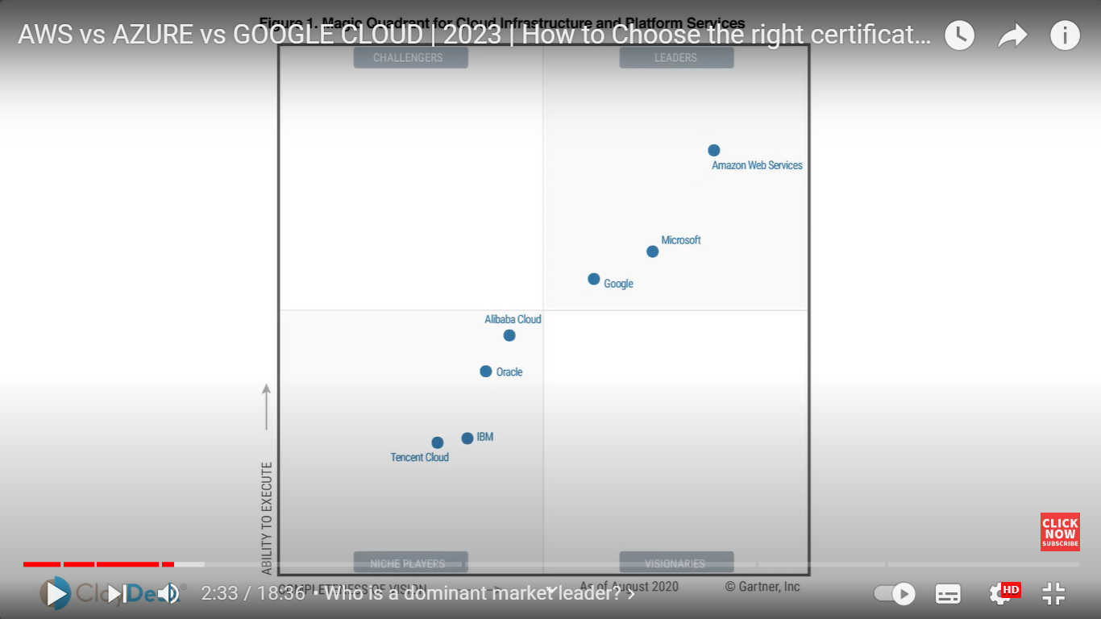

<https://www.youtube.com/watch?v=FXl6EuG7Wxs>

DEVOPS

<https://www.youtube.com/watch?v=mN-85fQkRAs> nice

<https://www.linkedin.com/feed/update/urn:li:activity:7113481299591380994/>

https://www.youtube.com/shorts/cm-B5813Oq8

### **DevOps tools such as Jenkins, Docker, Kubernetes, Jfrog, Grafanna, GitOps, ArgoCD. I am AZ-900 certified**

<https://www.youtube.com/watch?v=7BO6WDnXgik> nicely explained

<https://www.youtube.com/watch?v=XvtFppcynYM>

Google Certification

### **I'm a Google Cloud Platform enthusiast, always looking for new challenges and technologies. Believing in the data-driven culture,an aspiring Cloud Architect and Developer skilled in Google Cloud Platform with Rich Experience in DevOps ( Docker ,Kubernetes, Terraform and Jenkins).**

<https://topmate.io/prerit_munjal>

<https://www.arcassetz.com/aws-devops-solutions/>

<https://www.revolentgroup.com/blog/5-reasons-why-aws-devops-earn-so-much/>

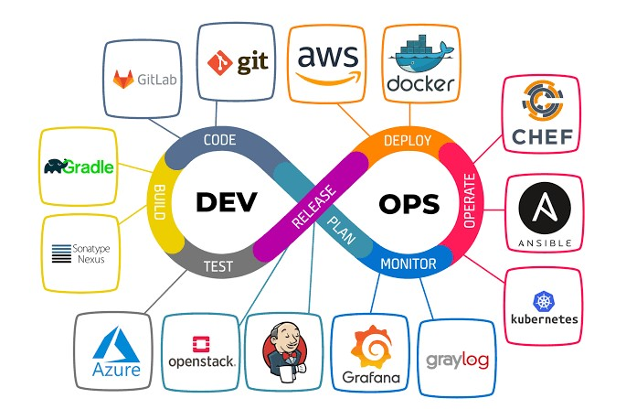

## What is AWS?

## Git. Aws ,Azure, openstack ,Grafana, graylog ,Kubernetes ,ansible, sonatype nexus ,gitlab, gradle, docker chef

Amazon Web Services is referred to as AWS. The AWS service is offered by Amazon, which makes various IT resources available on demand by using a distributed IT architecture. It provides multiple benefits, including packaged software as a service, infrastructure as a service, and platform as a service (SaaS). Amazon created the AWS cloud computing platform so that many businesses might benefit from dependable IT infrastructure.

AWS is one of several businesses’ most well-liked cloud computing platforms.

<https://www.edubridgeindia.com/blog/devops-vs-aws/>

[Amazon DevOps interview questions](https://www.edubridgeindia.com/blog/aws-devops-interview-questions/) will likely come up for anyone who works in software development or wants to start a career in cloud computing. The following websites are widely utilized to prepare for an AWS DevOps interview: Coursera, Edubridge, Interviewbit, Intellipat, Upgrad, etc.

Certainly! Here's an explanation of each of the terms you mentioned:

1. Git: Git is a distributed version control system used for tracking changes in source code during software development. It allows multiple developers to collaborate on a project and keep track of changes, making it easier to manage and merge code.

2. AWS (Amazon Web Services): AWS is a cloud computing platform provided by Amazon. It offers a wide range of cloud services, including computing power, storage, databases, machine learning, and more. AWS allows businesses to scale their IT infrastructure on-demand and run applications in the cloud.

3. Azure (Microsoft Azure): Azure is Microsoft's cloud computing platform. It provides services like virtual machines, databases, AI, and analytics tools, along with support for various programming languages, frameworks, and operating systems.

4. OpenStack: OpenStack is an open-source cloud computing platform used for creating and managing public and private clouds. It provides services for virtualization, storage, and networking, making it a flexible solution for cloud infrastructure.

5. Grafana: Grafana is an open-source platform for monitoring and observability. It is commonly used to create dashboards and visualize data from various sources, making it valuable for tracking system performance, application metrics, and more.

6. Graylog: Graylog is an open-source log management and log analysis platform. It helps organizations collect, store, and analyze log data from various sources to monitor system and application performance and troubleshoot issues.

7. Kubernetes: Kubernetes is an open-source container orchestration platform. It automates the deployment, scaling, and management of containerized applications. It's widely used for managing containers using Docker.

8. Ansible: Ansible is an open-source automation tool that simplifies application deployment, configuration management, and task automation. It uses simple, human-readable scripts (YAML) to define tasks.

9. Sonatype Nexus: Sonatype Nexus is a repository manager used for storing and managing software artifacts. It's often used to store dependencies for software development and ensure secure and efficient access to these artifacts.

10. GitLab: GitLab is a web-based platform for managing the entire software development lifecycle. It includes source code management with Git repositories, CI/CD pipelines, project management, and more.

11. Gradle: Gradle is a build automation tool used in software development. It allows developers to define and automate the build process for their projects, making it easier to compile, test, and package applications.

12. Docker: Docker is a platform for developing, shipping, and running applications in containers. Containers are lightweight, isolated environments that can run applications and their dependencies consistently across different systems.

13. Chef: Chef is an open-source configuration management tool used for automating the deployment and management of infrastructure and applications. It uses code (recipes and cookbooks) to define how systems should be configured.

These tools and platforms play crucial roles in modern software development and IT operations, making it easier to manage, deploy, and monitor applications and infrastructure.